Uniting Church in Australia
Western Australia
UCWA 101

Table of contents
Welcome to the Uniting Church in Australia 3
Our Commitment 3
Our Structure 3
The Uniting Church Western Australia (UCWA) 4
Social Justice 5
Multi-cultural and Cross-cultural Ministry 5
Safe Church 5
Commission for Education for Discipleship and Leadership 5
Uniting Aboriginal and Islander Christian Congress (UAICC) 6
Schools and Colleges 7
Methodist Ladies’ College (MLC) 7
Penrhos College 7
Presbyterian Ladies’ College (PLC) 7
Scotch College 8
St Stephen’s School 8
Tranby College 8
Wesley College 9
Trinity Residential 9
Western Australian Agencies 10
UnitingCare WA Forum 10
Good Samaritan Enterprises 10
Juniper 11
Uniting WA 11
Beananging Kwuurt Institute 12
Assembly Agencies 13
UnitingCare Australia 13
Frontier Services 13
UnitingWorld 13

Welcome to the Uniting Church in Australia
The Uniting Church in Australia (UCA) was formed on 22 June 1977, when the Congregational Union in Australia, the Methodist Church of Australasia and the Presbyterian Church of Australia joined together. The UCA understands its call as being to serve God’s passion for a better world as set out in the UCA’s way of living and being in the Basis of Union (https://assembly.uca.org.au/images/stories/HistDocs/basisofunion1971.pdf).
The UCA is the third largest Christian denomination in Australia, as well as the first church to be created in and of Australia.
The UCA is committed to flourishing as an intercultural church and enhancing opportunities for culturally and linguistically diverse (CALD) communities for inclusion and fuller participation in the life of the church.
As part of a congregation’s commitment to their local community, their community service activities can include emergency relief, financial counselling, op-shops, community and family support, playgroups, child-care centres, disability support, food centres, support for the aged, support for young parents, community education, low-cost computers, computer education, support for people affected by poverty or homelessness, refugee support, support for people affected by drugs or excessive alcohol and much more.
Even though our communities can be vastly different, each is a community of pilgrim people seeking to follow Jesus, learn about God, share their faith, care for each other, serve the local community and seek to live faithfully and with real joy.

Our Commitment
The Uniting Church in Australia is committed to compassion, justice, and reconciliation between people.
In the spirit of uniting we:
- celebrate the love of God given to all people
- proclaim and live out hope, love, peace, reconciliation, sustainability and freedom for all people
- accept all people as equals in leadership
- embrace diversity and are open to discussing controversial issues and what it means to be inclusive of all people and to respect differences
- are committed to dialogue and co-operation with other churches and participation in national and world ecumenical bodies such as the World Council of Churches
- are willing to explore the implications of being in a community of people of many faiths
- bring an open and informed faith to engage with a wide scholarly enquiry regarding emerging issues in contemporary society.

Our Structure
The Uniting Church is organised by groups of people, lay and ordained, consulting together, making decisions by consensus, in each area of the church’s life.
The church is committed to being a series of inter-related councils - local congregations, Presbytery, Synod and the National Assembly. Each Council has its distinct tasks, and each council recognises the limits of its responsibilities to other councils. The governance of the whole church happens through Presbytery and Synod committees and commissions, which report to the Presbytery and Synod meetings and in between to the Presbytery and Synod Standing Committees.

The Uniting Church Western Australia (UCWA)
The Uniting Church WA is composed of the Presbytery of Western Australia with more than 100 congregations, and the Synod of Western Australia with:
- Seven schools: Methodist Ladies’ College (MLC), Presbyterian Ladies’ College (PLC), Penrhos College, Scotch College, Wesley College, St Stephen’s School and Tranby College.
- A university residential college: Trinity Residential College and Conference Centre is located near the University of Western Australia.
- Four leading not-for-profit service agencies: Beananging Kwuurt Institute (BKI), Good Sammy Enterprises, Juniper, and Uniting WA.
Within Western Australia, the Synod of Western Australia serves an area of two million square kilometres covering most of the state. The Synod is the legal and administrative body of the church. The Presbytery of WA is responsible for pastoral oversight of its congregations.
Each week in Western Australia, more than one hundred congregations and faith communities worship with families, individuals, children, youth, and the elderly; in small or large gatherings; in rural or urban settings; culturally specific or diverse.
Worship styles vary from the traditional to the contemporary, with small groups sharing faith in homes, schools or centres of care.
Ministers and representatives of caring agencies, schools, and the Presbytery of WA meet annually (usually in September) to discuss issues affecting the whole of the state at Synod. Throughout the year, the work of the Synod continues through its committees, commissions, agencies, schools, and paid staff of the Uniting Church Centre.
- are committed to dialogue and co-operation with other churches and participation in national and world ecumenical bodies such as the World Council of Churches
- are willing to explore the implications of being in a community of people of many faiths
- bring an open and informed faith to engage with a wide scholarly enquiry regarding emerging issues in contemporary society.

Social Justice
The Uniting Church identifies itself as a justice-oriented church and has been actively involved in campaigns for justice for First People’s, refugees, LGBTIQA+ people, the climate and our international partners – just to name a few!
The Social Justice Unit helps connect people across the Uniting Church with information and ways to get involved in various issues. The Unit resources three commissions of the Uniting Church WA Synod: The Social Justice Commission, the Covenanting Commission and the International Partnerships and Development Commission.
Discover more about our Social Justice Unit Team in their “Did you know . . ” flyer and in our Social Impact section on our website.

Multi-cultural and Cross-cultural Ministry
The Uniting Church is committed to flourishing as a multi-cultural and inter-cultural church. In 1985, the Uniting Church Assembly made the declaration “We are a multicultural church.” We continue on our journey to fully realise what it means to be a multicultural church, living faith and life cross-culturally. For more information, visit our Multi-cultural and Cross-cultural Ministry page.

Safe Church
We are entrusted to provide a safe church environment. We believe that each one of us is precious to God and that in following Jesus’ example we are called to care for each other, especially when we are vulnerable. For more information about Safe Church and its training programs, please visit our Culture of Safety section.

Commission for Education for Discipleship and Leadership (CEDAL)
The Commission for Education for Discipleship and Leadership (CEDAL) is responsible for providing education to members to enable them to grow in faith, discipleship and leadership; oversight of theological education for the specified ministries of the Uniting Church (Lay Preacher, Pastor, Deacon and Minister of the Word) according to guidelines set by the Assembly.
Our overall aim is “to build an informed and integrated learning community directed to the mission of God”.
We offer theology courses with us and accredited study options for:
- people wishing to grow in faith and expand their discipleship
- leaders in local congregations who are called on to lead worship, preach, and share their faith
- people who feel a call to leadership in a specific form of ministry
- anyone wanting to undertake a formalised pathway of the study of theology
- Ministers who are actively seeking to develop their skills in ministry.

More information on how to become a minister and many other courses is available in our Study Theology section on our website.

Uniting Aboriginal and Islander Christian Congress (UAICC)
The Uniting Aboriginal and Islander Christian Congress (UAICC) was established in 1985 as the national Indigenous body of the Uniting Church in Australia (UCA). Congress is dedicated to seeking the spiritual, physical, social and emotional well-being of Indigenous Australians.
As an independent body, Congress determines its own goals and objectives and decides its policies and priorities. The Western Australian Regional Committee of the UAICC currently has two congregations, one in Coolbellup and another in Waroona, as well as an emerging ministry in Tammin.
In 1994, a Covenant was agreed upon between Congress and the UCA, and together, we continue to build a relationship between Indigenous and non-Indigenous members of the church and the wider community.
In 2009, the Uniting Church was the first church in Australia to constitutionally acknowledge Aboriginal and Torres Strait Islander peoples as the First Peoples of Australia in the preamble to the Uniting Church constitution. The change of the preamble signifies the natural and rightful extension of the covenantal relationship that the Uniting Church has with the Indigenous people of the church, and by extension of this land. For more background and resources about our Covenanting journey please visit the Assembly website (https://assembly.uca.org.au/covenanting).
In 2008, the Beananging Kwuurt Institute (BKI) was formally recognised as an Aboriginal community service organisation of the Uniting Church WA to bring hope and fresh heart to Aboriginal people in the WA community.
The Social Justice Unit at the Synod of WA supports the Covenanting Commission, a joint body between the Synod of WA and the WA Regional Committee of UAICC. You can make contact at social.justice@wa.uca.org.au.
The Uniting Church WA works with Congress on the following:
- the implementation of the recommendations of the Bringing Them Home Report through support for Bringing Them Home WA.
- Social Reinvestment WA to eliminate the over-representation of First Peoples in the justice system in Western Australia.
- policies that respect self-determination and the ability and desire of First Peoples to achieve their own changes and solutions.
- adoption of the Statement from the Heart, the establishment of a Voice to Parliament, and a Makarrata (agreement-making) Commission.
- the Boab Network, a sub-committee of the Creative Living Centre, is a registered not-for-profit charity with its own constitution and board which answers to the All Saints Floreat Uniting Church Council.

Schools and Colleges
The Uniting Church WA upholds, as a central purpose, a culture of lifelong learning in which formation for discipleship and leadership become prized, appreciated and accessible.
Excellent, holistic education for young people has been important to the Uniting Church WA since 1897 with the founding of Scotch College and continues today through seven schools, as well as Trinity Residential College.

Methodist Ladies’ College (MLC)
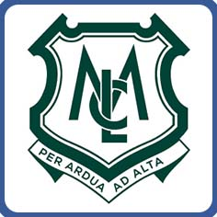
Methodist Ladies’ College is an all-girls day and boarding school offering education from six months of age in their Early Learning Centre through to year 12. The college, located in Claremont, celebrates diversity and achievement and promotes excellence in all areas of life.
MLC mentors motivated learners to choose purposeful futures and inspire students to embrace their uniqueness. The college holds integrity, mastery, enterprise and justice as its core values and aims to be an international leader in holistic learning and teaching.
Through smaller class sizes and specialised care from teachers, mentors and staff, every MLC student is individually catered for. Staff can get to know each girl as an individual, understand her abilities and aspirations, and inspire her to be her best.

Penrhos College
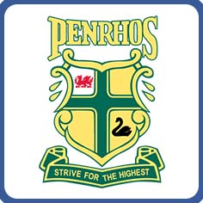
Penrhos College is a day and boarding school for girls, pre-kindergarten to year 12, located in Como, Western Australia. Penrhos’ purpose is clear – inspire girls to become extraordinary women. From the youngest girl in pre-kindergarten, who explores and discovers through play-based discovery in the Early Learning Centre, to the young woman in year 12 sitting her Western Australian Certificate of Education (WACE) exams, Penrhos delivers an inspirational learning environment in which each individual is encouraged to strive for the highest and achieve her personal best.
The Penrhos ethos extends far beyond the college’s renowned academic credentials, to encompass the ‘whole person paradigm’ with an educational philosophy focused on the nurture of mind, heart, body and spirit for a complete, rounded and balanced education in preparation for life.

Presbyterian Ladies’ College (PLC)
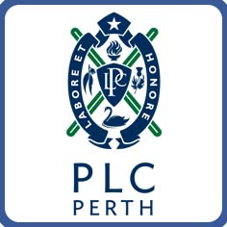
Presbyterian Ladies’ College is a pre-kindergarten to year 12 girls' school, located in Peppermint Grove. The college was founded in 1915 and has since sustained an international reputation for academic excellence and outstanding success in preparing young women to lead active, purposeful lives.
Evidence of PLC’s Scottish heritage is apparent in the distinct Black Watch tartan uniform and PLC Pipe Band, as well as in its belief in educational excellence, combined with a whole-of-person approach to intellectual, social, emotional and spiritual development.
PLC’s purpose is to provide an innovative, vibrant and challenging education that fosters personal excellence and builds an inclusive community of friends. PLC values a culture of learning for life and spiritual enquiry where character and leadership are nurtured to serve and shape the world.

Scotch College
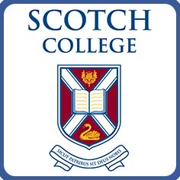
Scotch College is a day and boarding school for boys from pre-kindergarten to year 12. Located in Swanbourne, the college is one of Australia’s leading independent schools. With the core values of ‘service, stewardship, and integrity’, the college aims to develop young men with strength of character, self-understanding, a passion for sustained learning, and spiritual inquiry.
Throughout its history, Scotch College has upheld standards of Scotch excellence, which are reflected in the development of contemporary teaching, learning and pastoral care programs. The college teaches the Western Australian Curriculum while also delivering the International Baccalaureate Primary and Middle Years Programmes. At the year 11 and 12 levels, the college offers the Western Australian Certificate of Education (WACE) or the International Baccalaureate Diploma and is registered as an International Baccalaureate World School.

St Stephen’s School
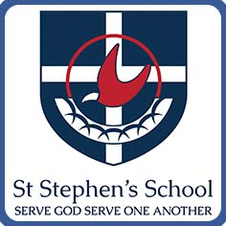
St Stephen’s School is a co-educational, pre-kindergarten to year 12 school located across three campuses in Duncraig and Carramar. Founded on a vision to nurture, St Stephen’s School aims to inspire learning that transforms lives.
St Stephen’s School students are encouraged to follow their passion toward success, whether it be via an academic, vocational or workplace route. There is a focus on developing life skills such as critical thinking, teamwork, agility and communication, so graduates enter the world ready to make an impact.
The community also enjoys a vibrant performing arts scene, dynamic sports subjects, outdoor education at the school’s rural property, The Kaadadjan Centre in Dwellingup, and a renowned Service Learning Program that aligns with the school’s motto to ‘Serve God, Serve One Another’.

Tranby College
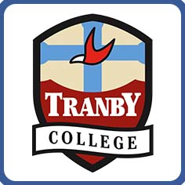
Tranby College is a progressive independent college that has delivered quality school education for boys and girls from kindergarten to year 12 for more than 23 years. Located south of Perth, Tranby College also has an onsite child-care centre that caters to children from six weeks to five years of age, facilitating a seamless transition into formal schooling.
Tranby dedicates itself to knowing each child and growing their abilities. The college supports, inspires and encourages by providing opportunities for every student to learn and discover new talents, passions and interests. Above all, they care about each child.
From kindergarten to year 12, Tranby’s learning approaches adapt to cater to the diverse and changing needs of students of different ages. The college’s well-being philosophy and caring are the keys to success with students.

Wesley College
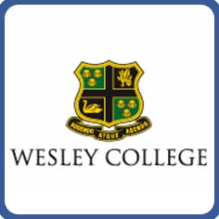
Wesley College is a day and boarding school that offers co-educational learning from pre-kindergarten to year 6 and is boys only from years 7 to 12. Founded in 1923, Wesley College is non-selective and egalitarian, welcoming students from all backgrounds – bound together by a shared desire to achieve personal excellence.
Wesley holds the core values of respect, integrity, courage and compassion. The motto ‘By Daring and By Doing’ is Wesley’s vision for inspiring students to be bold, seek personal excellence and serve others.
Wesley offers 30 to 40 needs-based Aboriginal and Torres Strait Islander scholarships through their Moorditj Mob program. The program is well-known in the public for the Moorditj Mob Dancers and didgeridoo players, who perform both at the college and external community events.

Trinity Residential
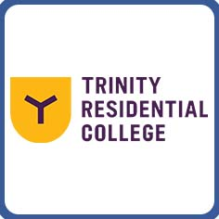
Trinity Residential College is an on-campus student accommodation college for Perth university and TAFE students. Trinity offers fully furnished private rooms for 380 students, each with a study area and balcony or doors that lead straight out to the quad.
Trinity is fully catered, and residents get to enjoy many social and sporting events which help to ensure residents become part of a community of like-minded friends with a genuine student support network. Residents also have access to free car parking, wi-fi, academic support, leadership opportunities and more. Accommodation includes access to an on-site gym, sports courts, music rooms and games tables.
Located in Crawley, Trinity is a two-minute walk from the University of Western Australia and is conveniently located for Kings Park, Matilda Bay, the Perth CBD and other Perth universities.

Western Australian Agencies

UnitingCare WA Forum
The UnitingCare WA Forum was established by the WA Synod to provide coordination of the Synod’s activities as part of the Church’s mission in community services and the Forum is the convocation of Good Sammy Enterprises; Juniper and Uniting WA.
The UnitingCare WA Forum facilitates the coordination of the activities and future plans of the UnitingCare WA Forum agencies within Synod.
It does so by advising the Synod of their strategic directions, policy frameworks and the overall planning for the church’s mission in community services within the Synod that expresses the theology and ethos of the Uniting Church.
Secondly, it advises Synod of any public statements, submissions and representations concerning matters of social policy and social advocacy in cooperation with the Social Justice Commission.
The Forum represents the WA Synod in relation to the broader UnitingCare Network throughout Australia.
The Forum usually meet four times a year and reports annually to the WA Synod and to the Synod Standing Committee as requested. The Forum has nomination rights to Synod Standing Committee.

Good Samaritan Enterprises
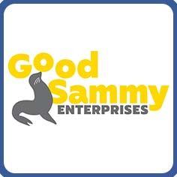
Good Sammy Enterprises’ (GSE) core purpose is to find meaningful employment for people living with a disability. Over 60 years, GSE has employed more than 5 000 people.
The Good Sammy Academy Team currently provide over 160 one-on-one mentorship and group activities to people with disability, to help develop life skills, build confidence and create pathways for employment. Good Sammy Enterprises also provides support and advice to families seeking help with the National Disability Insurance Scheme (NDIS) and ways to maximise their funding.
By receiving donations, Good Sammy’s redirects around 6 000 tonnes of used goods from entering landfill each year and continues to promote the message of reducing, reusing and recycling. In 2020, Good Sammy’s became one of WA’s key providers in the newly established Container Deposit Scheme, providing community recycling deposit centres.
Good Sammy’s 27 op-shops located from Albany to Geraldton are the public face of the organisation and allow supported employees to explore opportunities in the retail industry, as well as process the generous donations received from the community.

Juniper
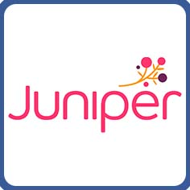
Juniper is a leading provider of care, accommodation and support services for older Western Australians. Since welcoming their first residents in 1949, Juniper has grown to employ over 1 800 staff and 200 volunteers. As a not-for-profit aged care provider, Juniper supports more than 3 000 Western Australians at every stage of the care journey, through retirement living, home and community care programs, and residential aged care services.
Juniper’s mission is to enhance the independence, spiritual fulfilment, and enjoyment of the life of older people through care, accommodation and support services.
In response to the increasing need, Juniper has a strong presence throughout metropolitan Perth, as well as the Kimberley, Mid-West, Wheatbelt and Great Southern regions.
Juniper is named after the hardy Juniper plant, known for its medicinal properties, deep cultural and biblical connections, and synonymous with shelter and sustenance.

Uniting WA
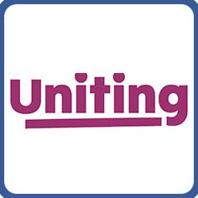
Uniting WA is a community services agency of the Uniting Church that touches the lives of thousands of Western Australian families and individuals each year.
Uniting WA works to address the causes of vulnerability and disadvantage and stands for a just society where individuals and communities are valued and connected. This work is underpinned by the Uniting WA foundation: Christ invites us to serve humanity by creating an inclusive, connected and just world.
As an organisation, Uniting WA celebrates diversity and welcomes all people regardless of ethnicity, faith, age, ability, culture, language, gender identity or sexual orientation.
Uniting WA services are available throughout the Perth metropolitan area, as well as in the Great Southern region of Western Australia.
The agency was founded as UnitingCare West in 2006 and began trading as Uniting WA in early 2020.

Beananging Kwuurt Institute
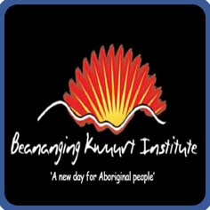
Beananging Kwuurt Institute (BKI) is an Indigenous charitable organisation based on the site of the former Sister Kate’s Children’s Home at Queens Park, Perth. BKI currently provides emergency and food relief to Indigenous people from the local community and operates an op-shop from its site. It also runs healing programs including art classes, children’s activities and communal meals.
It’s a joint initiative of the Synod of the WA Uniting Church in Australia and the WA Regional Committee of the Uniting Aboriginal and Islander Christian Congress (UAICC), the UCA’s Indigenous Ministry. It was constituted as an instrumentality of the Synod of WA and incorporated under s28 of the Uniting Church Act, 1976 (WA) on 23 September 2007.
“Beananging” is Nyungar for the beginning of a new day, the part of the day when the sky begins to come light, but before the sun has risen. “Kwuurt” is Nyungar for the heart. Beananging Kwuurt represents ‘A new day for Aboriginal people’ symbolising the place for healing, caring and nurturing.

Assembly Agencies

UnitingCare Australia
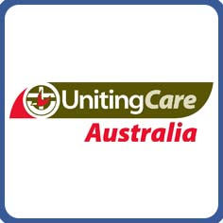
UnitingCare Australia is the national body for the Uniting Church’s community services network and an agency of the Assembly of the Uniting Church in Australia. The UnitingCare network is one of the largest networks of social service providers in Australia supporting 1.4 million people every year across 1 600 sites in urban, rural and remote communities through the work of 50 000 staff and 30 000 volunteers. In Western Australia, three agencies belong to the national UnitingCare network: Good Sammy Enterprises (or Good Sammy’s), Juniper and Uniting WA.

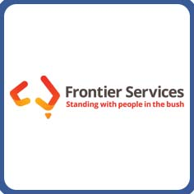
Frontier Services
Frontier Services is Australia's oldest bush charity, supporting those doing it tough in remote Australia by providing emotional, spiritual and practical care. Founded in 1912 by Rev John Flynn, Frontier Services strives to provide a mantle of safety and wellbeing to everyone who lives in regional and remote areas. This includes Indigenous communities, isolated properties, mining communities and other remotely located communities. Through Outback Links and Bush Chaplaincy, Frontier Services continues to implement Rev Flynn's vision for outback people by being the welcome visitor, the friend, the counsellor and the advocate for the people of remote Australia.
Whether it’s caretaking to property maintenance, gardening to painting, or mental health support - Outback Links strives to place volunteers across Australia. Currently, the Outback Links program supports over 1 200 volunteers nationwide providing support where it’s needed most.
Frontier Services Bush Chaplains are on the front lines, visiting people in regional areas to provide pastoral and practical care. Travelling tens of thousands of kilometres every year, Bush Chaplains do it all from popping in for a cuppa and a chat to organising emergency food relief and raising funds.

UnitingWorld
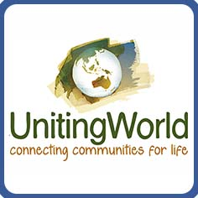
UnitingWorld is the international aid and partnerships agency of the Uniting Church in Australia. In response to God’s purpose for the world and its people, UnitingWorld connects the people of the Uniting Church in Australia in missional collaboration with churches overseas, strengthening the church to address the causes and consequences of poverty, injustice and violence.
Across the Pacific, Asia and Africa, UnitingWorld partners with Indigenous churches that are deeply rooted in their local communities. Responding to God’s call for justice, our partner churches serve their local communities, addressing injustice in lasting and meaningful ways. Working in partnership means those in the best position to assess the changing needs of their communities are driving the work.
UnitingWorld works alongside partners on shared projects, enhancing their capacity, addressing challenges, and helping implement community-led solutions. Thanks to funding from supporters, our partners can create lasting and meaningful change.
Each UnitingWorld project addresses one or more of the following themes:
- poverty alleviation
- leadership
- gender equality
- climate change and disaster risk reduction
- disaster response.

