A Handy Guide to

Mission Planning
The five marks of mission
Tell | Proclaim the Kingdom’s Good News
Teach | Teach, baptise, and nurture new believers
Tend | Respond to human need by loving service
Transform | Transform society’s unjust structures
Treasure | Safeguard the integrity of creation

This document is a companion to a larger document, “Mission Planning: Playing our Part in the Mission of God”. It provides a summary of how you may engage with the mission planning process.
There is space for making notes, which can act as a prompt as you plan. It is not a template because every congregation is unique, and your mission plan will not look like the mission plan of another congregation.
By using this document, you are being invited to reimagine how the Body of Christ can live and work in your unique context, to ask how you will engage with contemporary culture and with those people who are not already connected with the church.

Mission is good news!

Preparing
Decide to take this discernment seriously and agree to a time commitment. This may take anything between a few concentrated weeks and may even take up to a year.
Spend time listening to the preached word and spend time praying together.
Register for the Mission Shaped Ministry Course and keep a record of your ongoing conversations.
Think about who you need to resource you on this journey, for instance, leaders from within the congregation, Thrive Mission Committee, Presbytery Minister (Mission) or independent consultants.
Make a realistic timeline of what you need to achieve and when you hope to achieve it and choose a framework that works for your group so you can consider looking at identity, purpose and context through new eyes.
Your notes:

Gathering
As you listen to God’s word and pray together ask the Thrive Mission Committee to share the tool they have developed that will help in gathering information. The following data is important.
- National Church Life Survey
- Australian Bureau of Statistics – details of the community including how many UCA people are included in the census for your local area, local demographics and living arrangements.
- Local Government – make an appointment with your community development officer to find out about their priorities. What can you learn about your community, its strengths, its nature, its needs.
- Local history – what has your community been known for in the past?
- Local church history – Where has your church come from as a community of faith? This is not for nostalgia but to get a sense of what has shaped the congregation over the years.
- What has your church inherited in terms of identity, purpose, and context? Is this still relevant? How deeply does it find expression? Does it need to be honoured or celebrated? Does it need to be maintained or let go? How does this inform decisions about legacy?
- Church attendance data, details of church property and information of key people in the congregation, including those being paid as well as volunteers.
- Numbers of people served by the church, which includes attendance at various programmes, not just Sunday morning attendance.
- Financial information in an easy-to-understand format
- What other churches are there in your vicinity and what are they doing?
Your notes:

Listening
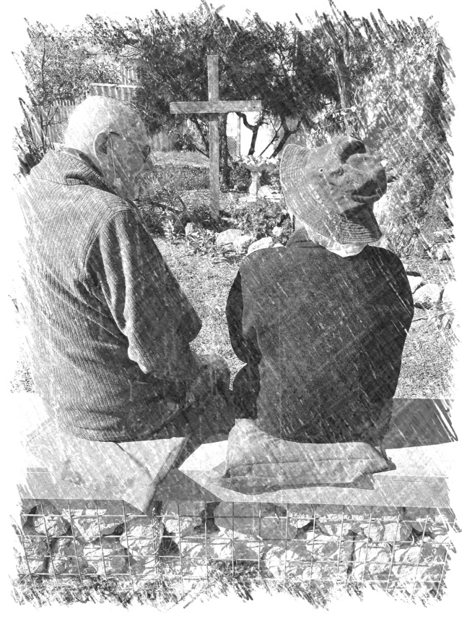
Listen for God’s voice, the voices of your neighbours and your neighbourhood, and to each other. Set aside special times when you can pray about the future of the church. Consider a day when people can drop into the church during the day to pray. Set up prayer stations around the church with information about the ideas that have been gleaned over the years, and information about the local community and its needs.
Do some surveys, using Survey Monkey as an online survey and also a paper version for those who prefer. In some cases, it may be better to do one-on-one interviews with individuals but to maintain consistency use the same questions you have used in other surveys.
Prepare a survey that you can use in your neighbourhood, then hold a barbecue, fete, or market day. Make it an enjoyable day but make good use of it to listen to what people think about the church.
When you’ve recorded all that, you’ve heard in your listening phase this is a good time to set up a meeting with the Presbytery Minister for Mission or a representative of Thrive Mission Committee to provide them with a snapshot of your Mission Planning process so far.
Your notes:

Visioning
Dream big. Imagine what the church is like when it’s at its best and what God may be saying to you.
Brainstorm outcomes, aspirations, and your sense of call as a community of faith. How can you be ‘on a mission’ with God? This is an opportunity for every wild idea to be heard and respected. A member of the Thrive Mission Committee or the Presbytery Minister (Mission) will be able to direct you to the enormous number of resources about the multiplicity of fresh expressions of church, mission projects and changes in structures and expectations that are involved in being the church in the 21st century.
This may require one or several “dreaming days” where you allow yourself to think beyond those things that currently restrain the church and its thinking.
It’s useful to have these ‘dreaming days’ in a different location to where you normally meet for business discussions. Hire a venue in your local community, use an outdoor venue, or find a place where you are not constrained by the things you’re used to, as this can often help in thinking differently about those things that are familiar.
Your notes:

Measuring
Measure your capacity as honestly and pastorally as possible; considering the people resources you have, how ready and available people are to be involved in mission, partnership opportunities and the physical resources of finance and property.
Spend time working at becoming clearer about the costs and opportunities. Develop a budget that is realistic as well as visionary.
Consider the barriers in the way and how they may be overcome.
Talk with other congregations or faith communities that have undertaken similar plans.
Some congregations find it useful to do a SWOT analysis, looking at your Strengths, Weaknesses, Opportunities and Threats.
Your notes:

Focusing
Now you have dreamed big and done some measuring it’s time to put them both together. Prayerfully discern a grand plan, focusing on the vision and determining together the overarching long-term goals.
Discern the immediate action plan, stepping out the strategies for resolving the resourcing that is required. Keep good documentation.
Test the call by ongoing discernment and by waiting for consensus and conviction. Consider trialling something for three to six months.
Apply to Thrive Mission Committee for a “start it up” grant to help you test the plan.
Keep the congregation involved throughout the process, always describing it in terms of your identity, purpose, and context – stay positive and excited.
Your notes:

Implementing
It’s time to get started. While planning is extremely important, there is danger in spending years talking and ultimately never starting anything. So get started!
Don’t be afraid of making mistakes. Sometimes failure is the best tool for re-focusing and finding a better way forward. It’s an opportunity to learn and start again.
Get your team together regularly to talk, eat together, plan and pray.
Create short videos to share with your congregation or take lots of photos and share them, asking people to pray with you and for you, and to support the plan wherever they can.
Share these on your Facebook page or website and with the Presbytery to encourage others.
Share the good things that are happening!
Be honest about the challenges and what opportunities the challenges may open. Use these opportunities to refine your project and planning.
Your notes:
Reviewing
Review it and do it again. God is always on mission!
Honestly and fairly review the Mission Plan and its effectiveness against the timeline and budget.
Ask open questions like: How could we have improved this? Do we still have a sense that God is calling us in this direction? What have we learned together? Who is willing to ask others to explore future options?
Review using the five marks of mission: To proclaim the good news of Jesus; to teach baptise and nurture new disciples; to respond to human need by loving service; to transform unjust structures of society, to challenge violence of every kind and pursue peace and reconciliation, and to strive to safeguard the integrity of creation and sustain and renew the life of the earth.
Look to the future: Who is willing to explore future options? What and who do we need to continue sharing in mission?
Your notes:

What’s required in a mission plan?
☐ | Preparing: | Provide an overview of how you conducted mission planning and what steps you took. What is the history of your congregation, and its mission?
☐ | Gathering: | Talk about your congregation - what you do, who makes up your ministry team or teams, where you’re located, and what facilities you have. (Some of this can be copied from your Church profile).  Provide demographics and significant data about your local neighbourhood and community, including any information that may have helped you to understand the nature of the community and how it affects the local church.
☐ | Listening: | What did you do during the mission planning process to hear the views of your congregation and the wider community about the future direction of the church? If you conducted surveys provide details of the results. How did you go about hearing the voice of God in prayer and Scripture?
☐ | Visioning: | As you have gone through the mission planning process outline the goals you have identified for future mission. Tell us about your dreams for the long term as well as shorter-term goals that may be stepping stones towards the larger dream. Have you identified any fresh expressions of church?
☐ | Measuring: | As you outline your dreams, identify who is responsible for implementation, when you see these goals being implemented as well as the steps in the process, and how you will know that you have achieved them.  Include a budget that shows how you intend to pay for and achieve the goals you have set
☐ | Focusing: | Your mission plan needs to be something that anyone can look at it in the future and see clearly what is anticipated, how those goals will be achieved and who is responsible for implementation. Review your mission plan to make sure it is in a format that is easily accessible and can be used to help the congregation, your ministry team or anyone else to get a snapshot of your congregation and how it is putting into practice the five marks of mission: Tell, teach, tend, transform, and treasure. Include some photos.
☐ | Implementing  and Reviewing: | You may not be able to include these in your mission plan yet, but remember it is a living document. Include a review date and include details of your implementation in the next mission plan.

