Strategic Planning Framework for the Uniting Church in Western Australia
2022 - 2027
Contents
Introduction 3
Biblical Principles 3
Choosing a Strategic Process 4
A Planning Methodology 4
Focusing on the Big Picture 5
The Purpose 5
The Vision 6
Five Focus Areas 7
Seven Core Values 9
Seven Focus Actions 11
The Focus Actions in Practice 12
Conclusion 14

Introduction
In revising the strategic framework of the Uniting Church in Western Australia, there is an awareness and sensitivity that we join hands as congregations, councils, agencies and schools, each with our existing understanding of God’s call upon our lives.
The strategic framework intends to be respectful towards this reality, whilst also acknowledging that we are more than just a group of individual parts, but collectively carry an identity of being part of a larger whole. It is therefore fundamentally important that we not only have a clear vision of who we are as individual parts but also as a collective whole.
Through the process of strategic planning, the intent is to create an opportunity where we can collectively discern and clarify whom we believe we are called to be as a larger whole, the Uniting Church in Western Australia. This framework aims to serve as a North Star that will provide us with the guardrails and parameters that will enable us to leverage the full value and sum of the whole, whilst also providing us with better clarity as to where we need to focus our time and resources as a Church.
For many years, strategic planning has helped mobilise organisations in achieving their goals by serving as a roadmap to visualise where they are going and how to get there. In his letter to the Church in Philippi, Paul emphasises how important it is, not to get caught up in distractions, but to remain focused on the goal ahead, saying “this one thing I do: forgetting what lies behind and straining forward to what lies ahead, I press on toward the goal for the prize of the heavenly call of God in Christ Jesus.” (Philippians 3:13-14).
Stephen Covey also cautions us that a lack of clear vision not only makes unity virtually impossible but leaves us being directed by our history, habits, moods, etc. In this regard, strategic planning is intended to be a mechanism towards maintaining our focus as “a pilgrim people, always on the way towards a promised goal.” (Basis of Union, Par. 3).

Biblical Principles
Looking at Scripture, planning is not a foreign concept in the Bible but is part and parcel of narratives like the creation, the exodus out of Egypt and the settling into the promised land, all the way through to Nehemiah and the rebuilding of Jerusalem’s wall and the parable of the ten bridesmaids, to name but a few.
  - God is portrayed as a Planner
From the creation narrative, right through scripture, God is portrayed as a planner. The Judaeo-Christian tradition also seems to understand this well, as is evident from the frequent use of verses like Jeremiah 29:11 “For I know the plans I have for you,” and Psalm 33:11 “But the Lord’s plans stand firm forever”. Jesus also affirmed the importance of planning. In Luke 14:28-32 we read Jesus’ words to a large crowd, saying: “Suppose one of you wants to build a tower. Will he not first sit down and estimate the cost to see if he has enough money to complete it?”
  - Strategic Planning is a Journey of Faith
In Ephesians 5:1 (NRSV) Paul calls us to “imitate God, in everything”. From this perspective strategic planning is not a separate venture to our journey with God, but an integrated part of who we are as a people of God.
Proverbs also offer some clarity on how this should be done. Firstly, plan with God. Seeking God’s will is essential in any planning. Proverbs 19:21 reminds us that: “The human mind may devise many plans, but it is the purpose of the Lord that will be established.” This is an essential point about planning for anyone who claims to have a Godly worldview. Proverbs also emphasise the wisdom in planning with others. Proverbs 15:22 cautions us by saying that “Without counsel, plans go wrong, but with many advisers, they succeed.”
Strategic planning is therefore not intended to be in opposition to faith, but an expression of intentional discernment as a Church community. It moves beyond our reliance on cognition and intellectual hard work to a place of deep listening and response to the Spirit. It also moves us beyond relying only on our ability to hear God’s voice and practising corporate discernment to affirm God’s will and direction. It is for this very reason that the DNA of the Uniting Church is to always be interrelated, aware of our limitations, and give heed to others (Refer: Basis of Union par. 15).

Choosing a Strategic Process
In deciding whether we should develop a Biblical model that speaks to the uniqueness of the church, or contextualise a more familiar secular model, there are probably no “right” or “wrong” answers, yet a decision still needs to be made. Having an identity of a church being called to serve God in this world, there is validity in adopting the language of the world that we are called the serve within, especially our schools and agencies with their unique call. For these reasons, it might be sensible to make use of a more familiar, existing model (and its vocabulary) that is already widely accepted and used by corporations and not-for-profit organisations, but at the same time also redefines some of the concepts within a Christian context.
This practice is nothing new to the church. Paul does the same in Acts 17:22-24 “Athenians, I see how extremely religious you are in every way. For as I went through the city and looked carefully at the objects of your worship, I found among them an altar with the inscription, ‘To an unknown god.’ What therefore you worship as unknown, this I proclaim to you. The God who made the world and everything in it, he who is Lord of heaven and earth, does not live in shrines made by human hands…” In a strategic context an example would be for instance the continued use of the term “Vision”, but to define it in terms of the church’s understanding that it is not “our vision” but “God’s vision” for us.

A Planning Methodology
Many metaphors help us describe the objectives of strategic planning. As we often describe ourselves as “a pilgrim people” the metaphor of a journey might be an appropriate and helpful image in this regard. As a pilgrim people towards a promised end, a strategic framework should serve as a mechanism to provide us with a clear picture of who we are, where we are going, and in which direction we need to head to reach our destination. In other words, the “Big Picture”.
This framework should enable us to remain focused on a shared vision and enable the individual parts to contribute towards this shared vision, each in their unique way within their strategic planning.

In other words:
- A clear understanding of the bigger picture.
- Articulating the purpose of our existence. In other words, WHY do we exist as a Church?
- Succinctly describing the vision of how we as a church will accomplish this purpose.
- Identifying what we need to do to maintain our focus, on the identified Vision.
- A clear understanding of who we are – our ethos.
- Defining our core values, the foundation of our character, attitude, and overall behaviour.
- A clear understanding of the immediate.
- Creating a framework through which each unique part can contribute towards the larger whole.
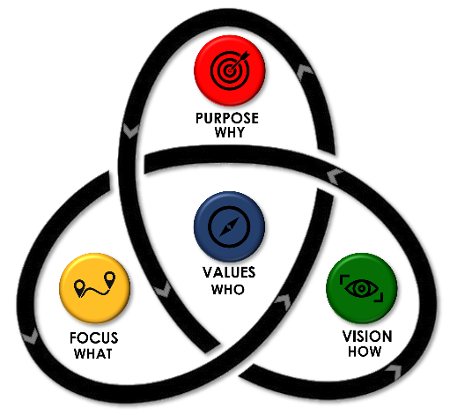
Figure 1: Vision Framework Process

Focusing on the Big Picture
Following an extended period of collective discernment, the Synod meeting in September 2021, articulated our awareness of the above as follows:

The Purpose
Why do we ultimately exist? What is God’s Purpose for us as a Church?
The Constitution Paragraph 4 defines “The purposes of the Church are to provide for the worship of God, to proclaim the Gospel of the Lord Jesus Christ, to promote Christian fellowship, to nurture believers in the Christian faith, to engage in mission, to assist in human development and toward the improvement of human relationships, to meet human need through charitable and other services and to do such other things as may be required in obedience to the Holy Spirit.” In short, we exist as a pilgrim people to glorify and love God above all and to love our neighbour as our self, as we journey towards God’s promised end.

The Vision
How can we best ensure to remain true towards these Godly purposes that define our existence?
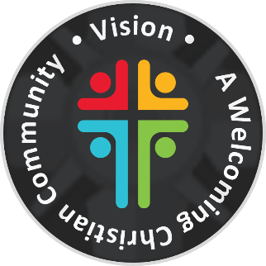
As a people of God, we want to move forward, with our eyes fixed upon Christ. The first paragraph of the Basis of Union begins by declaring that the formation of the Uniting Church in Australia was a prayerful act in seeking “the glory of God the Father, the Son and the Holy Spirit” and a willingness to continue to “obey God’s will.” (par 1). Similarly, Paul and Timothy also encouraged the Christians in Colosse, saying: “…whatever you do, in word or deed, do everything in the name of the Lord Jesus, giving thanks to God the Father through him.” (Colossians 3:17).
To accomplish these purposes, we envisioned a diverse community, reconciled with God and one another through Christ, glorifying God above. A space where God’s kingdom becomes visible, God can be known and God’s grace experienced, in other words, “A Welcoming Christian Community”.

Symbolism
The primary purpose of a logo is identification. Logos also serve as a reminder and offer the opportunity to communicate important messages.
A new vision logo was created to visualise the newly revised vision statement, without dramatically changing the look and feel of the current logo or existing colour palette:

Figure 2: New Vision Logo
The proposed new logo consists of four different figures with open arms, together they form the outline of a cross. The symbolic meeting of the elements represents:
The meaning of the symbols:
- Four different figures: A diverse community
- Open arms: A welcoming / serving / worshipping community
- Cross outline: A Christ-centred community

The meaning of the colours:
- Turquoise: Peace, compassion and wisdom
- Yellow: Joy, hope and creativity
- Green: Life, growth and renewal
- Red: Action, energy and passion

Five Focus Areas
Paul humbly states in Philippians 3:12-14 “Not that I have already obtained this or have already reached the goal, but I press on to lay hold of that for which Christ has laid hold of me. Brothers and sisters, I do not consider that I have laid hold of it, but one thing I have laid hold of: forgetting what lies behind and straining forward to what lies ahead, 1 press on toward the goal, toward the prize of the heavenly call of God in Christ Jesus.” This statement reminds us of the nature of strategic planning. We have not yet arrived; we are people on the way. It is a process that is never completed, and therefore we always need to remain open to the continuous leading of God’s Spirit.
In addition to having clarity about the purpose (why) and Vision (how), it is also important to identify what we will do to ensure we remain focused on the Vision, of being “A Welcoming Christian Community”. Following a period of discernment, five Focus Areas were identified:
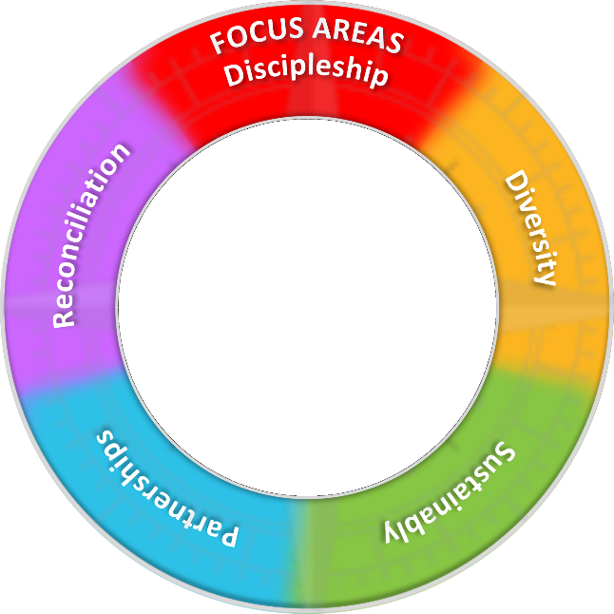
Figure 3: Focus Areas Wheel

Discipleship
To TEACH and PROCLAIM the Good News of Jesus Christ
“You yourselves are our letter of recommendation, written on our hearts, to be known and read by all. And you show that you are a letter from Christ delivered by us, written not with ink but with the Spirit of the living God, not on tablets of stone but on tablets of human hearts.” (2 Corinthians 3:2-3 NRSV)
Paragraph 1 of the Basis of Union states that as a church we commit ourselves to “hear anew the commission of the Risen Lord to make disciples of all nations, and daily to seek to obey his will”. We are called to do this “through human witness in word and action, and in the power of the Holy Spirit, Christ reaches out to command people’s attention and awaken faith; he calls people into the fellowship of his sufferings, to be the disciples of a crucified Lord” (para 4).
The Basis of Union concludes by stating that as “the people of God on the way to the promised end” the Uniting Church as a denomination commits itself to a life of “worship, witness and service to God’s eternal glory through Jesus Christ” (para 18).

Diversity
To EMBRACE and NURTURE all people and their gifts
“For there is no distinction between Jew and Greek; the same Lord is Lord of all and is generous to all who call on him.” (Romans 10:12, NRSV)
The Basis of Union echoes an awareness of diversity and the inclusive nature of God’s love, stating that it “believes that Christians in Australia are called to bear witness to a unity of faith and life in Christ which transcends cultural and economic, national and racial boundaries…” (para. 2). It also further “acknowledges with thanksgiving that the one Spirit has endowed the members of Christ’s Church with a diversity of gifts” (para. 13) and that the “congregation will recognise the need for a diversity of agencies for the better ordering of its life” (para. 15).

Sustainability
To SAFEGUARD and RENEW God’s creation with integrity
“Whenever the rainbow appears in the clouds, I will see it and remember the everlasting covenant between God and all living creatures of every kind…this is the sign of the covenant I have established between me and all life on the earth.” (Genesis 9:16, 17 NIV)
The Statement to the Nations declares that “We are concerned with the basic human rights of future generations and will urge the wise use of energy, the protection of the environment and the replenishment of the earth's resources for their use and enjoyment.”
This responsibility we understand from within the deeper perspective of the Basis of Union that states that “God in Christ has given to all people in the Church the Holy Spirit as a pledge and foretaste of that coming reconciliation and renewal which is the end in view for the whole creation.” (par 3).

Partnerships
To BUILD and GROW healthy interdependent relationships
“Therefore encourage one another and build up each other, as indeed you are doing.”
(1 Thessalonians 5:11 NRSV)
The commitment to reach out and join hands with others has been part of the Church’s DNA from the beginning. The Constitution of the Uniting Church emphasises this outward focus by stating that “The purposes of the Church are … to nurture believers in the Christian faith, to engage in mission, to assist in human development and toward the improvement of human relationships, to meet human need through charitable and other services and to do such other things as may be required in obedience to the Holy Spirit” (para. 4)
The Basis of Union also emphasises strengthening the Church “for their participation in the mission of Christ in the world” (para. 5&8) as “the Church of God is committed to serving the world” (para. 1).

Reconciliation
To SEEK JUSTICE and RECONCILIATION for all
“In Christ God was reconciling the world to himself, not counting their trespasses against them, and entrusting the message of reconciliation to us.” (2 Corinthians 5:19)
“In Jesus Christ, God was reconciling the world to himself” and as a Church, we are “seeking to bear witness” to this unity “which is both Christ’s gift and will for the Church” (Basis of Union, para 1&3). The Statement to the Nation further declares that “we believe this unity is a sign of the reconciliation we seek for the whole human race”. The preamble to the Constitution of the Uniting Church views in this regard the covenantal relationship with the Uniting Aboriginal and Islander Christian Congress “as a foretaste of that coming reconciliation and renewal which is the end in view for the whole creation”.

Seven Core Values
Not only is it important to know where we are going, but also whom we are called to be as a people of God. In his sermon on the mount, Jesus made it clear that not only is it important what we do, but also who we are, saying “You are the salt of the earth; but if salt has lost its taste, how can its saltiness be restored? It is no longer good for anything but is thrown out and trampled under foot” (Matthews 5:13).
Our ethos plays an enormous role in our ability to materialise our vision to be “A Welcoming Christian Community”. But what are those values that we would like to choose as our guiding compass?
Following a discerning process in which congregations, schools and agencies participated, 14 values were identified, which were perceived as core values of the Uniting Church. The Synod in Session in 2021 narrowed these down to seven core values, which were further defined at Summer Spirit early in 2022.
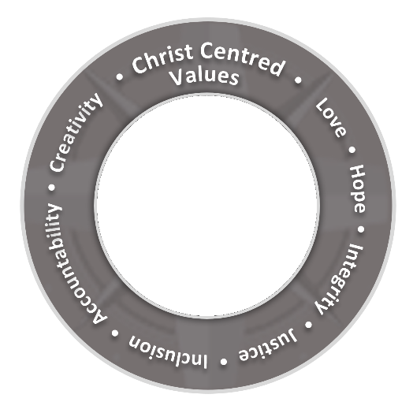
Figure 4: Values Wheel

Love
Love is the most essential Christian value in the Bible. God is love and through experiencing God’s unconditional love, we know what love is and can love as well. Godly love is sacrificial, it requires obedience to God and implies action. “Therefore be imitators of God, as beloved children, and walk in love, as Christ loved us and gave himself up for us, a fragrant offering and sacrifice to God.” (Ephesians 5:1-2)

Hope
Hope means to “trust and wait expectantly.” It is rooted in the love and faithfulness of God, and therefore not mere wishful thinking, but a firm assurance that God can be relied upon. Hope is trust in God, propelled by faith. Abraham was 75 years old when he first received God’s promise and 100 years of age when Isaac was born (Genesis 12:1-2 & 21:5).

Justice
Justice means “to make right.” It is a relational term that focuses on the qualities of our relationship with God, one another, and creation. Justice promotes fairness, equity, accessibility, opportunity, and the advancement of all while identifying and eliminating barriers. “Learn to do good; seek justice, correct oppression; bring justice to the fatherless, and plead the widow's cause” (Isaiah 1:17).

Inclusion
Inclusion embraces diversity and the characteristics that make people distinct from one another. It means understanding that God created each person as unique and calls us to recognise, respect and embrace these individual differences. The Bible is a story about inclusion, all who come through the gate into the sheepfold belong to the same flock (John 10:7-16).

Accountability
Accountability is about being responsible for fulfilling our duties and obligations as well as being willing to justify our actions with honesty and openness. Biblical accountability begins by taking the responsibility for one’s actions and making a conscious choice of allowing God - and others - to do what is right. The parable of the coins demonstrates this well (Luke 19:11-27).

Integrity
As people of integrity, we are uncompromising, transparent and consistent with the moral and ethical values we claim to embrace. We allow these values to shape who we are, what we say, as well as what we do. “But let your ‘Yes’ be ‘Yes,’ and your ‘No,’ ‘No.’” (Matthew 5:37).

Creativity
Through creativity, we imitate the creator God. We recognise, celebrate, and support the creativity of individuals and groups as we aim to have a meaningful impact on the large and complex challenges we face as the people of God. In Genesis 1 we are introduced to God as a creator God, who created us in this same image (Genesis 1:1 & 26).

Seven Focus Actions
Following the five strategic Focus Areas which were identified in 2021 to help us remain true to the formulated vision, a second consultation process was undertaken in 2022 to help put these Focus Areas into Action / Practice.
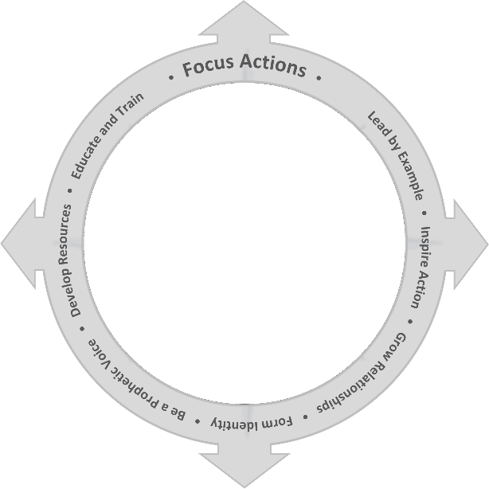
Figure 5: Focus Actions Wheel

While it was clear that the way these Focus Areas translate into Actions can differ significantly throughout the Church, depending on the specific context of councils, congregations, schools and agencies, it became clear that it could be grouped into categories that were the same across all five focus areas. These are:

Leading by Example
Leading by example, builds trust and respect, creates authenticity, and provides a picture of what is possible. As actions speak much louder than words, it is important to always be mindful of the message that is communicated through actions or the lack thereof.

Inspire Action
Corporate discernment is an integral part of the decision-making process, as it provides clarity and inspiration, it is however equally important that it translates into action. The apostle James writes that “faith by itself if it is not accompanied by action, is dead” (James 2:17 NIV). Discernment should always focus on inspiring action that will help turn convictions into reality.

Grow Relationships
Relationships are the cornerstone of human existence as they provide a space in which love is given and received. It involves immediate family and friends and includes wider groups, communities, and God.

Form Identity
Identity is formed through a process of exploring options and committing to an option, based on the outcome of the exploration. It provides for the structure to self-knowledge; alignment with beliefs, goals, and self-knowledge; a sense of continuity between history and the future; goals and direction as well as ownership over choices and outcomes.

Be a Prophetic Voice
A prophetic voice is more than insightful advice; it is ultimately to direct people towards God. Attuned to the Holy Spirit, is the ability to speak God’s truth into the current culture and context. Being Christ-centred is therefore essential to the ability of the Church to fulfil this God-given responsibility.

Develop Resources
Developing resources is ultimately an investment in the capacity of the church to remain sustainable and become more effective in pursuing God’s purpose for the church. This involves developing physical resources, as well as teaching and human resources.

Education and Training
Education and training are critical for developing as well as improving knowledge and capabilities, which promote effectiveness and productivity. This stimulates creativity, focus and problem-solving. Frequent education and training programs create the opportunity for regular re-evaluation.

The Focus Actions in Practice
The seven identified Focus Actions communicate the specific intent of our engagement in each of the five Focus Areas and provide a framework to articulate our engagement. Although these actions may greatly differ throughout the Church, reflecting the uniqueness of the various part, they will serve the same intent, focus areas and ultimately, the vision of the Church as a whole to be “A Welcoming Christian Community”.
Using SMART (specific, measurable, achievable (or attainable), relevant, and time-based) goals, as well as well-established tools such as SWOT (strengths, weaknesses, opportunities, and threats) and Pestle Analysis (political, economic, social, technological, legal and environmental), that can be very useful in this process, as it helps to formulate actions that also provide lenses through which we can better understand ourselves and the external environment
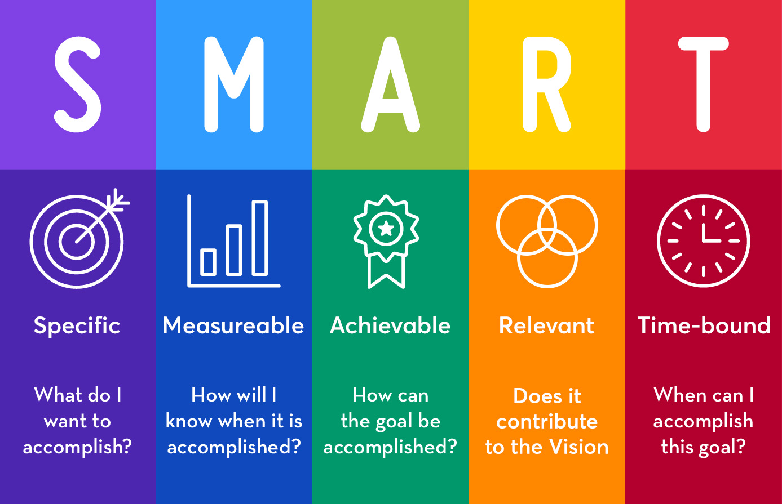
Figure 6: SMART (specific, measurable, achievable, relevant, and time-based) diagram

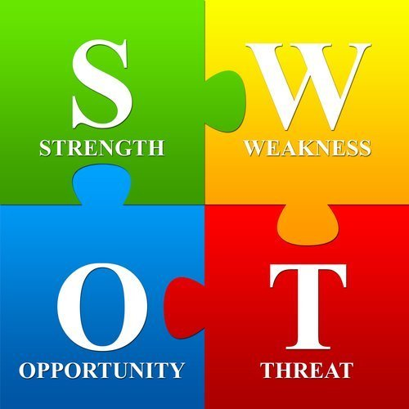
Figure 7: SWOT (strengths, weaknesses, opportunities, and threats) diagram

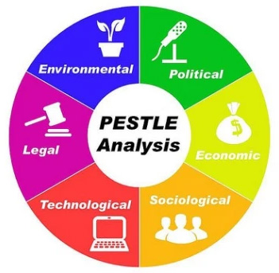
Figure 8: Pestle Analysis (political, economic, social, technological, legal and environmental) diagram

Conclusion
Although this process requires time, effort and commitment, we would like to believe that the benefits will outweigh the investment, assisting the church in:
- Clearly articulating a shared vision for the Uniting Church in Western Australia.
- Enable us to remain focused on what we believe we are called to be as a people of God.
- Provide a framework that will enable the various parts of the Church to identify and articulate how they can uniquely contribute towards the shared vision.
- Drawing us closer together as we jointly discern and work towards a shared vision.
- Assist us in prioritising resources and support.
Although the journey will have many challenges, it is also an exciting new time as we prepare ourselves for a new adventure as God’s people for this time in the life of the Church.

Hannes Halgryn
Associate General Secretary (Strategy)
hannes.halgryn@wa.uca.org.au

